

# NATIONAL UNIVERSITY OF SCIENCES AND TECHNOLOGY

SCHOOL OF MECHANICAL AND MANUFACTURING ENGINEERING

MECHANICAL ENGINNERING (ME-15)

# PROGRAMMING:

Home task #1

**SUBMITTEED BY: MUHAMMAD ALI SHOUKAT**

**REGISTRATION NUMBER: 457397**

**Task 1:**

#include<iostream>

using namespace std;

int main(){

int arr[10];

cout<<"enter your desired 10 integers "<<endl;

for(int i=0;i<=9;i++){

cin>>arr[i];

}

for(int i=0;i<=9;i++){

cout<<arr[i]<<" ";

}

return 0;

}

**Output:**

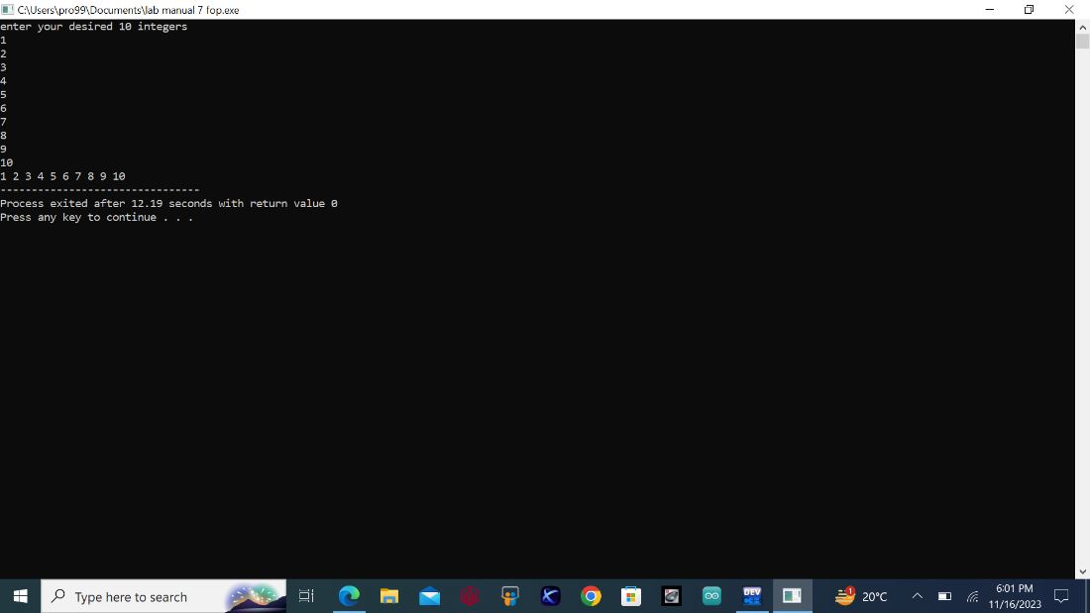

**Task 2:**

#include<iostream>

using namespace std;

int main(){

int arr[5];

cout<<"enter your desired 5 integers to find out their sum and product"<<endl;

int sum=0,product=1;

for(int i=0;i<=4;i++) {

cin>>arr[i];

sum+=arr[i];

product*=arr[i];

}

cout<<"the sum of the entered integers is "<<sum<<endl;

cout<<"the product of the entered integers is "<<product<<endl;

return 0;

}

**Output:**

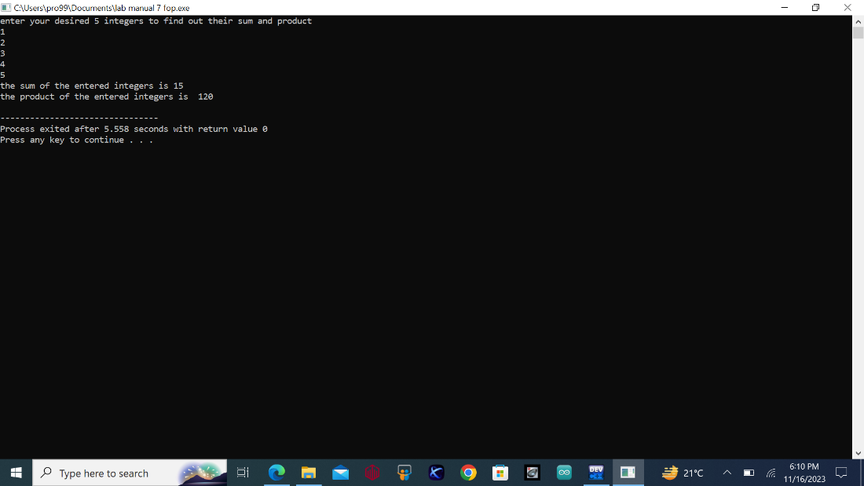

**Task 3:**

#include<iostream>

using namespace std;

int main(){

int rows,half;

char shape[half];

cout<<"enter the number of rows upto make a diamond"<<endl;

cin>>rows;

half=rows/2;

if(rows%2==0){

cout<<"enter an odd number of rows to get a proper shape";

return 1;

}

for(int i=0;i<rows;i++){

shape[i]=' ';

}

for(int i=0;i<half+1;i++){

for(int j=0;j<rows;j++){

shape[half-i]='*';

shape[half+i]='*';

cout<<shape[j];

}

cout<<endl; }

for ( int i=half;i>=0;i--){

for(int j=0;j<rows;j++){

shape[half-i]=' ';

shape[half+i]=' ';

cout<<shape[j];

}cout<<endl;

}

return 0;

}

**Output:**

